2024 BPEI 18U “A” RULES
Roster Rules
- Players must be 18U-aged (turn 16-, 17- or 18-years-old during 2024).
- Only 18U -aged players on a team’s roster can pitch; no Affiliated Players are permitted to pitch. - If an Association is fielding two 18U teams, there must be at least two nights set aside for 18U games. If a team does not have a regulation field within their own Association, they can use a field in another association provided they have at least one evening set aside for their own games
Game Rules
- Games will be seven (7) innings.
- For all regular season and exhibition games, if the game is still taking place after the two-hour mark, the inning the game is currently in will be finished, and no new innings will be started.
- For all regular season and exhibition games, if the score is tied after seven (7) innings, the game will remain tied. No extra innings will be played.
- Teams must use Rawlings ROML baseballs, and wooden bats. (Follow Baseball Canada Bat rules)
- Teams will bat all players and have unlimited defensive substitutions. - There is a five (5) run maximum per innings except in the seventh inning (“open” inning).
- Official Baseball PEI Pitch Count Rules will be in effect:
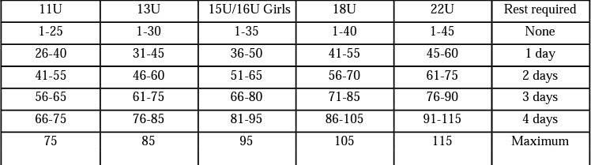
Provincials Eligibility
- The regular season must be completed no later than August 5, 2024, Tier 2/Best of 3 series will be on Aug 19-21th if needed, and the Provincial Championships will be from August 26-29 2024.
- Teams must complete their schedule to be eligible for the Provincials Championships.
Miscellaneous Rules
- After each game (deadline: 12pm/noon the next day) the home team must record the game score, names of pitchers for both teams, the pitch count (for both teams) and the names of both umpires on their team page on the Baseball PEI new RAMP website. www.baseballpei.com
- The home team is to provide two (2) brand new ROML baseballs for each game, and two (2) good condition “gently used” baseballs.

